CRISIS MANAGEMENT AND ALARM SYSTEM
(CMAS)

A PROJECT REPORT

Submitted By
Ashwin M
Mukesh Kumar S
Siva Hari Ganesan S

in partial fulfillment for the award of the degree
Of
BACHELOR OF TECHNOLOGY
In
INFORMATION TECHNOLOGY

SRI SAIRAM ENGINEERING COLLEGE,CHENNAI
ANNA UNIVERSITY :: CHENNAI 600044

ANNA UNIVERSITY : 600044

BONAFIDE CERTIFICATE

Certified that this project report “Crisis Management And Alarm System ” is bonafide work of “ Ashwin M, Mukesh Kumar S,Siva Hari Ganesan S” who carried out the project work under my supervision.

SIGNATURE SIGNATURE
Dr.T.Sheela, Asst.Professor.T.Subha,
HEAD OF THE DEPARTMENT, SUPERVISOR
Information Technology, Information Technology
Sri Sairam Engineering College,
Chennai-600044

TABLE OF CONTENTS
CHAPTER TITLE PAGE NO

ABSTRACT i
TABLE OF CONTENTS ii
1 INTRODUCTION
1.1 AIM OF THE PROJECT
1.2 PURPOSE
1.3 EXISTING SYSTEM
1.4 PROPOSED SYSTEM
2 SYSTEM REQUIREMENTS
2.1 HARDWARE REQUIREMENTS
2.2 SOFTWARE REQUIREMENTS
2.3 HARDWARE DESCRIPTION
2.3.1 MOBILE DEVICE
2.3.2 USB CONNECTOR
2.4 SOFTWARE DESCRIPTION
2.4.1 ANDROID SDK
2.4.2 ANDROID STUDIO
2.4.3 ANDROID ADB
2.4.4 XAMP SERVER
3 PROJECT DESCRIPTION
3.1 SYSTEM ARCHITECTURE
3.2 MODULE DESCRIPTION
3.3 SHORT DESCRIPTION
4 IMPLEMENTATION
4.1 SOURCE CODE
4.1.1 SOFTWARE MODULE
4.1.1.1 USER INTERFACE

5 SCREESHOTS
5.1 LAUNCHER
5.2 REGISTRATION
5.3 DATABASE STRUCTURE 5.4 SYSTEM ARCHITECTURE
5.5 REGISTRED DATABASE ENTRY
5.6 XAMPP CONTROL PANEL

6 CONCLUSION
7 REFERENCES

ABSTRACT :

Human Population is constantly under threat from natural disasters .In this study, an early warning system is being developed with capability of mobile platform can be used by various users to report Disasters. In the event of crisis proper guidance needs to be provided to the general public to prevent casualties. The civilians should be directed to the refugee center for their own safety and to avoid chaos. Lack of proper medium for Government to communicate with the civilians in distress is the primary reason to why Government fails in crowd control. Often civilians are stranded in the event of crisis due to the ignorance of evacuation or rescue plans of the Government. They need to be directed to a safe location to avoid panic among themselves. The Technical virtuoso of mobile platform is exploited to provide personal information to public. Mobile platform is picked as it provides widespread personal reach to guide civilians in the affected region. The Mobile numbers of civilians in the crisis region are extracted from VLR’s of local service provider. SMS Gateway is used to interface between the system and mobile network’s SMSC (Short Message Service Center). The information is passed as text messages.

- INTRODUCTION

CHAPTER-I
INTRODUCTION

1.1 AIM OF THE PROJECT
Human population is under constant threat from disaster. The nature of the disaster influences the kinds of threats that humans are exposed to by physical phenomena such as extreme weather, seismic, volcanic and human activities like terrorism and riots. Lack of proper medium for government to communicate with the civilians in distress is the primary reason to why government fails to crowd control. Often civilians are stranded in the event of crisis due to their ignorance of the evacuation or rescue plans of the government. They need to be directed to a safe location to avoid panic among themselves.

1.2 PURPOSE
In the event of a crisis, the project would be able to provide proper guidance to the general public to prevent casualties. The civilians can be directed to a refuge center for their own safety. Mobile platform is used because it can provide a widespread personal reach to guide civilians in the affected region. There is no available method for an individual to immediately report a crisis.

1.3 EXSISTING SYSTEM
The existing system does not support any specific feature that enables any form of notification or warning to be passed between the general public and the government. The Government can communicate with the general public only though social media like News. There is no available method by which a civilian can report a crisis immediately to the concerned authority.

1.4 PROPOSED SYSTEM

The technical virtuoso of the mobile platform is exploited to provide personal information to the public. The mobile numbers of the civilians in the crisis region are extracted from the VLR’s of local service providers. The SMS gateway is used to interface between the system and mobile network’s SMSC(Short Message Service Center). The information is passed as text messages.
The main objective of the proposed system is to :
- Provide a personal reach to pass information between the government and the public.
- Provide Maintenance free system
- Cost effective
- Make delivery of relief messages assured.

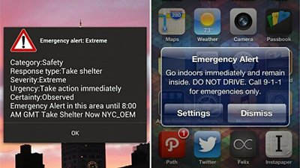
Figure 1.4 Proposed System in Android OS

- SYSTEM REQUIREMENTS

CHAPTER 2
SYSTEM REQUIREMENTS

2.1 HARDWARE REQUIREMENTS

• Personal Computer
• Mobile device.
• Mobile USB Connector

2.2 SOFTWARE REQUIREMENTS

• Android Studio
• Android SDK
• Android ADB
• Xampp server
• Notepad++
• Windows 7
• Php 5.6.3
• Mysql 5.6

2.3 FEATURES OF THE HARDWARE

2.3.1 MOBILE
A mobile device is also referred to as hand held devices. Hand held device or hand held computer is a pint-sized computing device and usually come with a touch or non-touch display screen and sometimes, even a mini keyboard. The mobile device should support the Android Operating System for performing multi-tasking, good user interface and rich notifications.

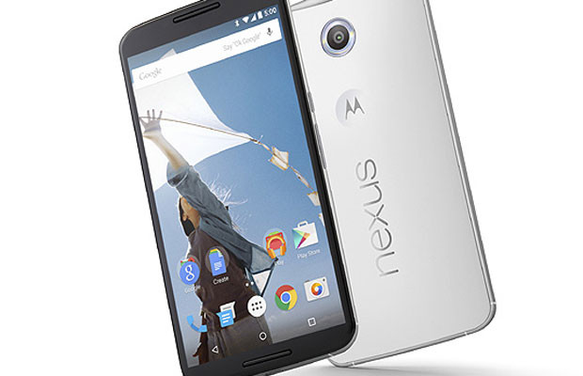
Figure 2.1 Mobile device with Android OS

2.3.2 USB CONNECTOR

Universal Serial Bus (USB) is an industry standard that defines the cables, connectors and communication protocols used in a bus for connection, communication and power supply between computers and electronic devices. Connecting a USB device to a computer is simple -- you find the USB connector

on the back of your machine and plug the USB connector into it. If it's a new device, the operating system auto-detects it and asks for the driver disk. If the device has already been installed, the computer activates it and starts talking to it. USB devices can be connected and disconnected at any time. Many USB devices come with their own built-in cable, and the cable has an "A" connection on it. If not, then the device has a socket on it that accepts a USB "B" connector.

2.4 SOFTWARE DESCRIPTION

2.4.1. ANDROID STUDIO

Android Studio is the official IDE for Android application development, based on IntelliJ IDEA. On top of the capabilities you expect from IntelliJ, Android Studio offers:
- Flexible Gradle-based build system
- Build variants and multiple apk file generation
- Code templates to help you build common app features
- Rich layout editor with support for drag and drop theme editing
- lint tools to catch performance, usability, version compatibility, and other problems
- ProGuard and app-signing capabilities
- Built-in support for Google Cloud Platform, making it easy to integrate Google Cloud Messaging and App Engine

2.4.2 ANDROID SDK

Android is a software stack for mobile devices that includes an operating system, middleware and key applications. The Android SDK provides the tools and APIs necessary to begin developing applications on the Android platform using the Java programming language. A software development kit that enables developers to create applications for the Android platform. The Android SDK includes sample projects with source code, development tools, an emulator, and required libraries to build Android applications. Applications are written using the Java programming language and run on Dalvik, a custom virtual machine designed for embedded use which runs on top of a Linux kernel.

FEATURES

- Application framework enabling reuse and replacement of components
- GSM Telephony (hardware dependent)
- EDGE, 3G, and Wi-Fi (hardware dependent)
- GPS, compass, and accelerometer (hardware dependent)
- Rich development environment including a device emulator, tools for debugging, memory and performance profiling, and a plugin for the Android Studio

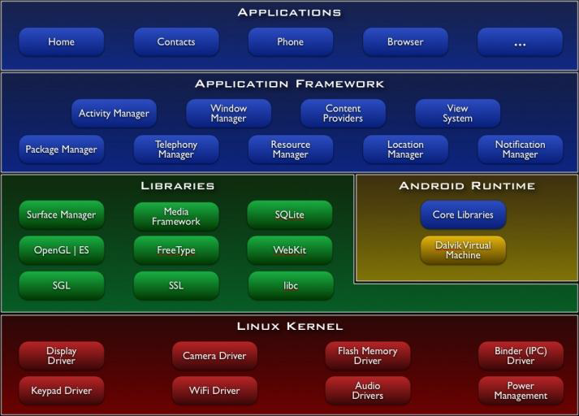
Figure2.5. Android Architecture

2.4.2 ANDROID ADB
Android Debug Bridge (adb) is a versatile command line tool that lets you communicate with an emulator instance or connected Android-powered device. It is a client-server program that includes three components:
A client, which runs on your development machine. You can invoke a client from a shell by issuing an adb command. Other Android tools such as the ADT plugin and DDMS also create adb clients.

A server, which runs as a background process on your development machine. The server manages communication between the client and the adb daemon running on an emulator or device.
A daemon, which runs as a background process on each emulator or device instance.

2.4.3 XAMPP SERVER

Xampp version 3.2.1 is an easy to install Apache distribution containing MySQL, PHP and Perl. It contains: Apache, MySQL, PHP & PEAR, Perl, ProFTPD, phpMyAdmin, OpenSSL, GD, Freetype2, libjpeg, libpng, gdbm, zlib, expat, Sablotron, libxml, Ming, Webalizer, pdf class, ncurses, mod_perl, FreeTDS, gettext, mcrypt, mhash, eAccelerator, SQLite and IMAP C-Client.
Once XAMPP is installed, it is possible to treat a localhost like a remote host by connecting using an FTP client. Using a program like FileZilla has many advantages when installing a content management system (CMS) like Joomla or WordPress. It is also possible to connect to localhost via FTP with an HTML editor.
The default FTP user is "newuser", the default FTP password is "wampp". The default MySQL user is "root" while there is no default MySQL password.

- PROJECT DESCRIPTION

CHAPTER 3
PROJECT DESCRIPTION
3.1 SYSTEM ARCHITECTURE:

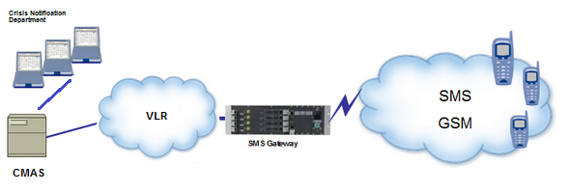

Figure 3.1 Overall Block Diagram

3.2 MODULE DESCRIPTION:

The project mainly contains of 3 modules, each of which enable this system enact a proper interface between the public and the government relief centers. The modules are given as follows:
- User registration module
- Report Crisis
- Authenticate Crisis and send Alarm

3.3 SHORT DESCRIPTION:
3.3.1 User registration module:

This module is used to register the mobile number of the user to the database. It uses php as middle tier to connect the database. The mainactivity class contains EditText element to get the user’s mobile number and a button that triggers register class’s execute method.
Register class is used to display the progress window while registeration is in progress. JsonParser class is used to create database connection and register user’s mobile number. It receives the response object from the database as json object it parses the object to retrieve the success of registration.

Cofig.php used to set up database credentials.
Connect.php used to connect to database
Register.php used to insert into database

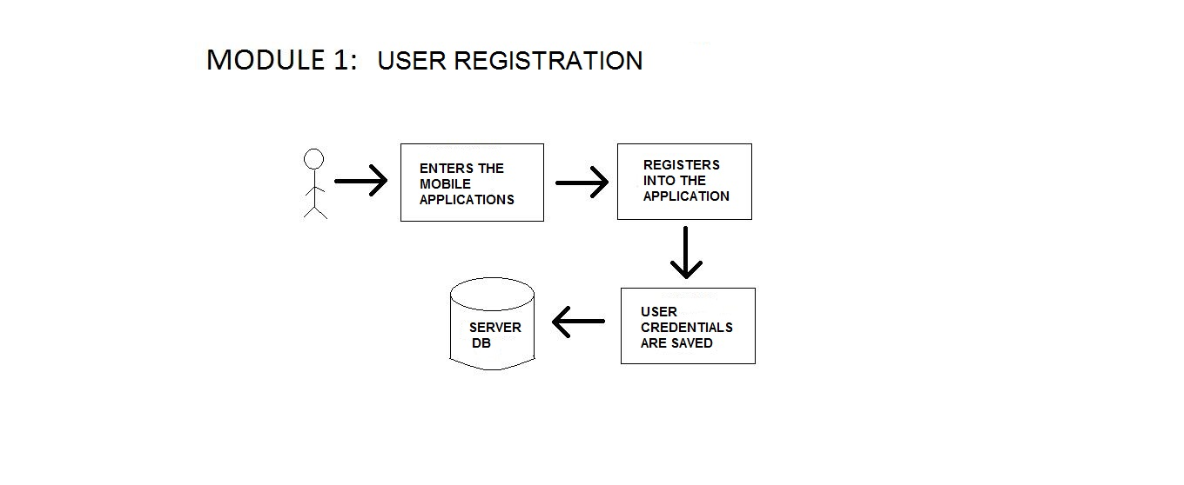
3.3.2 Report Crisis:

In the event of any crisis, this module will enable the user to report the event to a nearby government facility. The Government facility in turn can make the necessary steps to handle the situation. These action are accomplished by booting an application window in which the user can enter the crisis occurred. The Gps present in the device can notify the center on the coordinates of the device.

DisplayActivity.java is contains editText element to get the crisis from user

Gps is used to detect the location of user and is used to send the crisis report

along with the location and mobile number to the webserver.

3.3.3 Authenticate Crisis and send Alarm:

The crisis reported by user is verified and authenticated for its validity. Then the registered mobiles are sent a push notification to activate the app and get the location of the registered users. These users are in turn reported of the crisis in the affected region through alarm message which are sent via sms gateways.

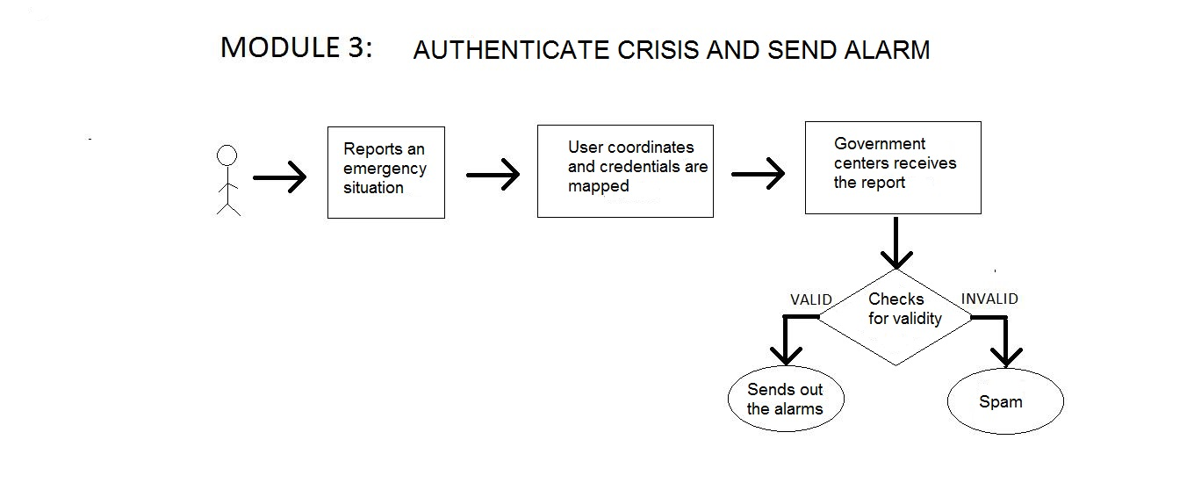

- IMPLEMENTATION

CHAPTER 4
MODULE 1
  - SOURCE CODE

4.1.1 SOFTWARE MODULES

The User Interface that registers user mobile number to XAMPP database through the android SDK.

4.1.1.1 USER INTERFACE

JsonParser.java
package com.gpsapp.shg.gpsapplicationtest.register;

import android.util.Log;

import org.apache.http.HttpEntity;
import org.apache.http.HttpResponse;
import org.apache.http.NameValuePair;
import org.apache.http.client.ClientProtocolException;
import org.apache.http.client.entity.UrlEncodedFormEntity;
import org.apache.http.client.methods.HttpGet;
import org.apache.http.client.methods.HttpPost;
import org.apache.http.client.utils.URLEncodedUtils;
import org.apache.http.impl.client.DefaultHttpClient;
import org.json.JSONException;
import org.json.JSONObject;

import java.io.BufferedReader;
import java.io.IOException;
import java.io.InputStream;
import java.io.InputStreamReader;
import java.io.UnsupportedEncodingException;
import java.util.List;

/**
* Created by HP on 01-03-2015.
*/
public class JSONParser
{
static InputStream inputStream=null;
static JSONObject jsonObject=null;
static String json="";
public JSONParser()
{
}

public JSONObject makeHTTPRequest(String url, String method, List<NameValuePair> parameters)
{
try
{
if(method=="POST")
{
DefaultHttpClient httpClient=new DefaultHttpClient();
HttpPost httpPost=new HttpPost(url);
httpPost.setEntity(new UrlEncodedFormEntity(parameters));

HttpResponse httpResponse=httpClient.execute(httpPost);
HttpEntity httpEntity=httpResponse.getEntity();
inputStream=httpEntity.getContent();
}
else if (method=="GET")
{
DefaultHttpClient httpClient=new DefaultHttpClient();
String paramString= URLEncodedUtils.format(parameters,"utf-8");
url+="?"+paramString;
HttpGet httpGet=new HttpGet(url);

HttpResponse httpResponse=httpClient.execute(httpGet);
HttpEntity httpEntity=httpResponse.getEntity();
inputStream=httpEntity.getContent();
}
}
catch (UnsupportedEncodingException e)
{
e.printStackTrace();
}
catch (ClientProtocolException e)
{
e.printStackTrace();
}
catch (IOException e)
{
e.printStackTrace();
}
try
{
BufferedReader reader=new BufferedReader(new InputStreamReader(inputStream,"iso-8859-1"),8);
StringBuilder stringBuilder=new StringBuilder();
String line=null;
while ((line=reader.readLine())!=null)
{
stringBuilder.append(line+"\n");
}
inputStream.close();
json=stringBuilder.toString();
}

catch (UnsupportedEncodingException e)
{
e.printStackTrace();
}
catch (IOException e)
{
e.printStackTrace();
}
try
{
Log.e("My Error", "JSON init started");
jsonObject=new JSONObject(json);
Log.e("My Error", "JSON initialised");
}
catch (JSONException e)
{
Log.e("My Error line 110",e.getLocalizedMessage());
e.printStackTrace();
}
return jsonObject;
}
}

UserInterfaceActivity.java
package com.gpsapp.shg.gpsapplicationtest;

import android.app.ProgressDialog;
import android.content.Context;
import android.content.Intent;
import android.content.SharedPreferences;
import android.location.Location;
import android.os.AsyncTask;
import android.os.Bundle;
import android.support.v7.app.ActionBarActivity;
import android.util.Log;
import android.view.Menu;
import android.view.MenuItem;
import android.view.View;
import android.widget.Button;
import android.widget.EditText;
import android.widget.ProgressBar;
import android.widget.Toast;

import com.gpsapp.shg.gpsapplicationtest.register.CMAS;
import com.gpsapp.shg.gpsapplicationtest.register.DBOperation;
import com.gpsapp.shg.gpsapplicationtest.register.GPSTracker;
import com.gpsapp.shg.gpsapplicationtest.register.JSONParser;

import org.apache.http.NameValuePair;
import org.apache.http.message.BasicNameValuePair;

import org.json.JSONException;
import org.json.JSONObject;

import java.util.ArrayList;
import java.util.List;

public class MainActivity extends ActionBarActivity implements View.OnClickListener {
public final static String EXTRA_MESSAGE = "com.gpsapp.shg.MESSAGE";
private ProgressDialog progressDialog;
JSONParser jsonParser=new JSONParser();
private int success;
private DBOperation dbOperation=DBOperation.getInstance();
private static Context mainContext;
private String message,latitude,longitude;
private EditText textMobileNumber;
private Button btnRegister;
private static String registerUrl="http://192.168.1.6/GPSJSON/register.php";
private static final String successTag="success";
@Override
protected void onCreate(Bundle savedInstanceState)
{
final String PREFS_NAME = "PrefsFile";
SharedPreferences settings = getSharedPreferences(PREFS_NAME, 0);
if (!dbOperation.isUserRegistered())
{
//here the app is being launched for first time, launch your screen
settings.edit().putBoolean("app_first_time", false).commit();
super.onCreate(savedInstanceState);
setContentView(R.layout.activity_main);
textMobileNumber= (EditText) findViewById(R.id.edit_message);
btnRegister= (Button) findViewById(R.id.register);
}
else
{
super.onCreate(savedInstanceState);
//setContentView(R.layout.activity_display_message);
Intent intent = new Intent(MainActivity.this, DisplayMessageActivity.class);
startActivity(intent);
finish();
}
}
@Override
public void onClick(View view)
{
if (view.getId()==R.id.register)
{
mainContext=this;
new RegisterMobile().execute();
}
}

@Override
public boolean onCreateOptionsMenu(Menu menu) {
// Inflate the menu; this adds items to the action bar if it is present.
getMenuInflater().inflate(R.menu.menu_main, menu);
return true;
}
@Override
public boolean onOptionsItemSelected(MenuItem item)
{
// Handle action bar item clicks here. The action bar will
// automatically handle clicks on the Home/Up button, so long
// as you specify a parent activity in AndroidManifest.xml.
int id = item.getItemId();
//noinspection SimplifiableIfStatement
if (id == R.id.action_settings) {
return true;
}

return super.onOptionsItemSelected(item);
}
public void sendMessage(View view)
{
if (view.getId()==R.id.register)
{
mainContext=this;
Location location=new GPSTracker().getLocation();
latitude=Double.toString(location.getLatitude());
longitude=Double.toString(location.getLongitude()); dbOperation.registerUser(textMobileNumber.getText().
toString(),latitude,longitude);
new RegisterMobile().execute();
}
}
class RegisterMobile extends AsyncTask<String,String,String>
{
String mobileNumber=textMobileNumber.getText().toString();
@Override
protected void onPreExecute()
{
super.onPreExecute();
progressDialog=new ProgressDialog(MainActivity.this);
progressDialog.setMessage("Registering New Mobile Number("+mobileNumber+")...");
progressDialog.setIndeterminate(false);
progressDialog.setCancelable(true);
progressDialog.show();
}
protected String doInBackground(String... args)
{
List<NameValuePair> parameters=new ArrayList<NameValuePair>();
parameters.add(new BasicNameValuePair("MobileNumber",mobileNumber));
parameters.add(new BasicNameValuePair("latitude",latitude));

parameters.add(new BasicNameValuePair("longitude",longitude));
JSONObject jsonObject=
jsonParser.makeHTTPRequest(registerUrl,"GET",parameters);
try
{
success=jsonObject.getInt(successTag);
message=jsonObject.getString("message");
Log.e("My Error",message+success);
}
catch (JSONException e)
{
e.printStackTrace();
}
return null;
}
protected void onPostExecute(String url)
{
progressDialog.dismiss();
if (success==1)
{
Log.e("My Error","Success");
Toast.makeText(getApplicationContext(),"New Mobile Number Saved....",Toast.LENGTH_LONG).show();
Intent intent = new Intent(mainContext, DisplayMessageActivity.class);
EditText editText = (EditText) findViewById(R.id.edit_message);
String message = editText.getText().toString();
intent.putExtra(EXTRA_MESSAGE, message);
startActivity(intent);
finish();
}
else
{
Toast.makeText(getApplicationContext(),"New Mobile Number Failed To Save....",Toast.LENGTH_LONG).show();
}
}
}
}

DBAccess.java
package com.gpsapp.shg.gpsapplicationtest.register;

/**
* Created by HP on 08-03-2015.
*/
import android.content.Context;
import android.database.sqlite.SQLiteDatabase;
import android.database.sqlite.SQLiteOpenHelper;
import android.util.Log;

public class DBAccess extends SQLiteOpenHelper
{
/* table for storing the user details */
public static final String USER_TABLE="userTable";
public static final String USER_TABLE_COLUMN_1_MOBILE="mobilenumber";
public static final String USER_TABLE_COLUMN_2_LATITUDE="latitude";
public static final String USER_TABLE_COLUMN_3_LONGITUDE="longitude";
/* database file name and version */
private static final String DATABASE_NAME="CMAS.db";
private static final int DATABASE_VERSION=1;

/*create table sql query string for USER_TABLE */
public static final String CREATE_USER_TABLE="create table "+USER_TABLE+" ("+USER_TABLE_COLUMN_1_MOBILE+" text primary key,"+
USER_TABLE_COLUMN_2_LATITUDE+" text,"+USER_TABLE_COLUMN_3_LONGITUDE+" text);";
public DBAccess(Context context)
{
super(context,DATABASE_NAME,null,DATABASE_VERSION);
}

@Override
public void onCreate(SQLiteDatabase sqliteDatabase)
{
sqliteDatabase.execSQL(CREATE_USER_TABLE);
}

@Override
public void onUpgrade(SQLiteDatabase sqliteDatabase, int oldVersion, int newVersion)
{
Log.w(DBAccess.class.getName(),"Upgrading database from the old version "+oldVersion+
" to the new version "+newVersion+" ,which will destroy the old data");
sqliteDatabase.execSQL("drop table if exists "+USER_TABLE);
}
}

DBOperation.java
package com.gpsapp.shg.gpsapplicationtest.register;

import android.content.ContentResolver;
import android.content.ContentValues;
import android.content.Context;
import android.database.Cursor;
import android.database.sqlite.SQLiteDatabase;
import android.util.Log;

import java.math.BigInteger;

/**
* Created by HP on 08-03-2015.
*/

public class DBOperation
{
private static SQLiteDatabase database;
private static DBAccess dbAccess;
private static DBOperation dbOperation=new DBOperation(CMAS.getContext());
private ContentResolver contentResolver;

public DBOperation(Context context)
{
dbAccess=new DBAccess(context);
contentResolver=context.getContentResolver();
}
/*
* @return the instance of the DBOperation class
*/
public static DBOperation getInstance()
{
return dbOperation;
}
/*
* @return the instance of SQLiteDatabase
*/
public static SQLiteDatabase getDatabase()
{
return database;
}
/*
* Opens the database connection
*/
public void openConnection()
{
if(database==null || !database.isOpen())
{
database=dbAccess.getWritableDatabase();
}
}
/*
* Closes the database connection
*/
public void closeConnection()
{
database.close();
}
/*
* @param mobile number of the user
* Inserts the user details into the USER_TABLE
*/
public void registerUser(String mobileNumber,String latitude,String longitude)
{
try
{
openConnection();
ContentValues values=new ContentValues();

values.put(DBAccess.USER_TABLE_COLUMN_1_MOBILE,mobileNumber);
values.put(DBAccess.USER_TABLE_COLUMN_2_LATITUDE,latitude);
values.put(DBAccess.USER_TABLE_COLUMN_3_LONGITUDE,longitude);
database.insert(DBAccess.USER_TABLE, null, values);
}
finally
{
//closeConnection();
}
}
/*
* @return true if there is any user registered
* @return false if there is no user registered
*/
public boolean isUserRegistered()
{
openConnection();
boolean operationResult=false;
Cursor cursor=null;
try
{
cursor=database.rawQuery("select "+DBAccess.USER_TABLE_COLUMN_1_MOBILE+" from "+DBAccess.USER_TABLE, null);
if(cursor.moveToNext())
{
operationResult=true;
}
else
{
operationResult=false;
}
}
finally
{
if(cursor!=null)
{
cursor.close();
//closeConnection();
}
}
return operationResult;
}
/*
* @return the mobile number of the user
*/
public String getMobileNumber()
{
String mobileNumber="";
Cursor cursor=null;
try
{
openConnection();

cursor=database.rawQuery("select "+DBAccess.USER_TABLE_COLUMN_1_MOBILE+" from "+DBAccess.USER_TABLE, null);
if(cursor.moveToNext())
{
mobileNumber=cursor.getString(0);
}
else
{
mobileNumber=null;
}
}
finally
{
if(cursor!=null)
{
cursor.close();
}
//closeConnection();
}
return mobileNumber;
}
public String getLatitude()
{
String latitude="";
Cursor cursor=null;
try
{
openConnection();
cursor=database.rawQuery("select "+DBAccess.USER_TABLE_COLUMN_2_LATITUDE+" from "+DBAccess.USER_TABLE, null);
if(cursor.moveToNext())
{
latitude=cursor.getString(0);
}
else
{
latitude=null;
}
}
finally
{
if(cursor!=null)
{
cursor.close();
}
//closeConnection();
}
return latitude;
}

public String getLongitude()
{
String longitude="";
Cursor cursor=null;
try
{
openConnection();
cursor=database.rawQuery("select "+DBAccess.USER_TABLE_COLUMN_3_LONGITUDE+" from "+DBAccess.USER_TABLE, null);
if(cursor.moveToNext())
{
longitude=cursor.getString(0);
}
else
{
longitude=null;
}
}
finally
{
if(cursor!=null)
{
cursor.close();
}
//closeConnection();
}
return longitude;
}
/*
* @param latitude of location
* @param longitude of location
* Updates location of the user
*/
public void updateUserLocation(String latitude,String longitude)
{
try
{
openConnection();
ContentValues values=new ContentValues();
values.put(DBAccess.USER_TABLE_COLUMN_2_LATITUDE, latitude);
values.put(DBAccess.USER_TABLE_COLUMN_3_LONGITUDE,longitude);
Log.e("DataBase Error","Test");
database.update(DBAccess.USER_TABLE,values,null,null);
}
finally
{
//closeConnection();
}
}
/*
* @return true if the database is opened
* @return false if the database is closed
*/

public boolean isOpen()
{
if(database.isOpen())
{
return true;
}
else
{
return false;
}
}
}
CMAS.java
package com.gpsapp.shg.gpsapplicationtest.register;

import android.app.Application;
import android.content.Context;

/**
* Created by HP on 08-03-2015.
*/
public class CMAS extends Application
{
private static Context context;

@Override
public void onCreate()
{
super.onCreate();
context = getApplicationContext();
}

public static Context getContext()
{
return context;
}
}

GPSTracker.java
package com.gpsapp.shg.gpsapplicationtest.register;

import android.app.AlertDialog;
import android.app.Service;
import android.content.Context;
import android.content.DialogInterface;
import android.content.Intent;
import android.location.Location;
import android.location.LocationListener;
import android.location.LocationManager;
import android.os.Bundle;

import android.os.IBinder;
import android.provider.Settings;
import android.util.Log;

/**
* Created by HP on 08-03-2015.
*/
public class GPSTracker extends Service implements LocationListener
{
private Location location;
private final Context context;
private boolean isGPSEnabled,isNetworkEnabled,canGetLocation;
private double latitude,longitude;
private DBOperation dbOperation=DBOperation.getInstance();
private static final long MIN_DISTANCE_CHANGE_FOR_UPDATES = 1000*10;//10 km
private static final long MIN_TIME_BW_UPDATES = 1000 * 60 * 30;
protected LocationManager locationManager;
public GPSTracker()
{
context=CMAS.getContext();
getLocation();
}
public Location getLocation()
{
try
{
locationManager = (LocationManager) context.getSystemService(LOCATION_SERVICE);
isGPSEnabled = locationManager.isProviderEnabled(LocationManager.GPS_PROVIDER);
isNetworkEnabled =locationManager. isProviderEnabled(LocationManager.NETWORK_PROVIDER);
if (isNetworkEnabled)
{
canGetLocation = true;
locationManager.
requestLocationUpdates(LocationManager.NETWORK_PROVIDER, MIN_TIME_BW_UPDATES,MIN_DISTANCE_CHANGE_FOR_UPDATES, this);
Log.d("Location", "Network Location");
if (locationManager != null)
{
location = locationManager.
getLastKnownLocation(LocationManager.NETWORK_PROVIDER);
}
if (location != null)
{
latitude = location.getLatitude();
longitude = location.getLongitude();
}
}
else if (isGPSEnabled)
{
canGetLocation = true;

locationManager.
requestLocationUpdates(LocationManager.GPS_PROVIDER,MIN_TIME_BW_UPDATES,MIN_DISTANCE_CHANGE_FOR_UPDATES, this);
Log.d("Location", "GPS Location");
if (locationManager != null)
{
location = locationManager.
getLastKnownLocation(LocationManager.NETWORK_PROVIDER);
}
if (location != null)
{
latitude = location.getLatitude();
longitude = location.getLongitude();
}
}
else
{
showSettingsAlert();
}
}
catch (Exception e)
{
e.printStackTrace();
}
return location;
}
@Override
public void onLocationChanged(Location location)
{
latitude=location.getLatitude();
longitude=location.getLongitude();
dbOperation.
updateUserLocation(Double.toString(latitude),Double.toString(longitude));
}
@Override
public void onProviderDisabled(String provider) {
}

@Override
public void onProviderEnabled(String provider) {
}

@Override
public void onStatusChanged(String provider, int status, Bundle extras) {
}

@Override
public IBinder onBind(Intent arg0) {
return null;
}
public void showSettingsAlert()
{
AlertDialog.Builder alertDialog = new AlertDialog.Builder(context);

alertDialog.setTitle("GPS settings");
alertDialog.setMessage("GPS is not enabled. Do you want to go to settings menu?");
alertDialog.setPositiveButton("Settings", new DialogInterface.OnClickListener()
{
public void onClick(DialogInterface dialog,int which)
{
Intent intent = new Intent(Settings.ACTION_LOCATION_SOURCE_SETTINGS);
context.startActivity(intent);
}
});
alertDialog.setNegativeButton("Cancel", new DialogInterface.OnClickListener()
{
public void onClick(DialogInterface dialog, int which)
{
dialog.cancel();
}
});
alertDialog.show();
}
public void stopUsingGPS()
{
if(locationManager != null)
{
locationManager.removeUpdates(GPSTracker.this);
}
}

}
ReportCrisis.java
package com.gpsapp.shg.gpsapplicationtest;

import android.app.ProgressDialog;
import android.content.Context;
import android.content.Intent;
import android.os.AsyncTask;
import android.support.v7.app.ActionBarActivity;
import android.os.Bundle;
import android.util.Log;
import android.view.MenuItem;
import android.view.View;
import android.widget.EditText;
import android.widget.TextView;
import android.widget.Toast;
import com.gpsapp.shg.gpsapplicationtest.register.DBOperation;
import com.gpsapp.shg.gpsapplicationtest.register.GPSTracker;
import com.gpsapp.shg.gpsapplicationtest.register.JSONParser;
import org.apache.http.NameValuePair;

import org.apache.http.message.BasicNameValuePair;
import org.json.JSONException;
import org.json.JSONObject;
import java.util.ArrayList;
import java.util.List;

public class DisplayMessageActivity extends ActionBarActivity implements View.OnClickListener
{
public final static String EXTRA_MESSAGE = "com.gpsapp.shg.MESSAGE";
private ProgressDialog progressDialog;
JSONParser jsonParser=new JSONParser();
private int success;
private String message;
private EditText textCrisis;
private static String registerUrl="http://192.168.1.6/GPSJSON/sendCrisis.php";
private static final String successTag="success";
private DBOperation dbOperation=DBOperation.getInstance();
private static Context mainContext;

@Override
protected void onCreate(Bundle savedInstanceState)
{
super.onCreate(savedInstanceState);
setContentView(R.layout.activity_display_message);
}

@Override
public boolean onOptionsItemSelected(MenuItem item)
{
// Handle action bar item clicks here. The action bar will
// automatically handle clicks on the Home/Up button, so long
// as you specify a parent activity in AndroidManifest.xml.
int id = item.getItemId();
//noinspection SimplifiableIfStatement
if (id == R.id.action_settings)
{
return true;
}

return super.onOptionsItemSelected(item);
}
@Override
public void onClick(View view)
{
if (view.getId()==R.id.register)
{
mainContext=this;
Log.e("My Error","Entered click");
textCrisis=(EditText) findViewById(R.id.edit_crisis);
new SendCrisis().execute();
}
}

public void sendCrisis(View view)
{
if (view.getId()==R.id.send)
{
mainContext=this;
Log.e("My Error","Entered click");
textCrisis=(EditText) findViewById(R.id.edit_crisis);
new GPSTracker().getLocation();
new SendCrisis().execute();
}
}
class SendCrisis extends AsyncTask<String,String,String>
{
String mobileNumber=dbOperation.getMobileNumber();
String crisis=textCrisis.getText().toString();
String latitude=dbOperation.getLatitude();
String longitude=dbOperation.getLongitude();
@Override
protected void onPreExecute()
{
super.onPreExecute();
progressDialog=new ProgressDialog(DisplayMessageActivity.this);
progressDialog.setMessage("Sending Crisis...");
progressDialog.setIndeterminate(false);
progressDialog.setCancelable(true);
progressDialog.show();
}
protected String doInBackground(String... args)
{
List<NameValuePair> parameters=new ArrayList<NameValuePair>();
parameters.add(new BasicNameValuePair("MobileNumber",mobileNumber));
parameters.add(new BasicNameValuePair("crisisMessage",crisis));
parameters.add(new BasicNameValuePair("latitude",latitude));
parameters.add(new BasicNameValuePair("longitude",longitude));
JSONObject jsonObject=
jsonParser.makeHTTPRequest(registerUrl,"GET",parameters);
try
{
success=jsonObject.getInt(successTag);
message=jsonObject.getString("message");
Log.e("My Error", message + success);
}
catch (JSONException e)
{
e.printStackTrace();
}
return null;
}
protected void onPostExecute(String url)
{
progressDialog.dismiss();
if (success==1)
{
Log.e("My Error","Success");
Toast.makeText(getApplicationContext(), "Crisis Sent....",
Toast.LENGTH_LONG).show();
Intent intent = new Intent(mainContext, DisplayMessageActivity.class);
startActivity(intent);
finish();
}
else
{
Toast.makeText(getApplicationContext(),"Sending Crisis Failed....",Toast.LENGTH_LONG).show();
}
}
}
}
Config.php
<?php
/* * All database connection variables */
define('DB_USER', "root");
define('DB_PASSWORD', "");
define('DB_DATABASE', "CMAS");// database name
define('DB_SERVER', "localhost"); // db server
?>
Connect.php
<?php
/**
* A class file to connect to database
*/
class DB_CONNECT
{
// constructor
function __construct()
{
// connecting to database
$this->connect();
}
// destructor
function __destruct()
{
// closing db connection
$this->close();
}
/**
* Function to connect with database
*/
function connect()
{
// import database connection variables
require_once __DIR__ . '/config.php';
// Connecting to mysql database
$con = mysql_connect(DB_SERVER, DB_USER, DB_PASSWORD) or

die(mysql_error());
// Selecing database
$db = mysql_select_db(DB_DATABASE) or die(mysql_error()) or die(mysql_error());
// returing connection cursor
return $con;
}
/**
* Function to close db connection
*/
function close()
{
// closing db connection
mysql_close();
}
}
?>
Register.php
<?php //insertnew.php
/*
* Following code will create a new product row
* All product details are read from HTTP GET Request
*/
// array for JSON response
$response = array();
// check for required fields
if (isset($_GET["MobileNumber"]))
{
$MobileNumber = $_GET['MobileNumber'];
$latitude = $_GET['latitude'];
$longitude = $_GET['longitude'];
// include db connect class
require_once __DIR__ . '/connect.php';
// connecting to db
$db = new DB_CONNECT();
// mysql inserting a new row
$result = mysql_query("INSERT INTO GPSLocation(MobileNumber,latitude,longitude) VALUES('$MobileNumber','$latitude','$longitude')");
// check if row inserted or not
if ($result)
{
// successfully inserted into database
$response["success"] = 1;
$response["message"] = "new Mobile Number saved....";
// echoing JSON response
echo json_encode($response);
}
else
{
// failed to insert row
$response["success"] = 0;
$response["message"] = "Oops! An error occurred.";

// echoing JSON response
echo json_encode($response);
}
}
else
{
// required field is missing
$response["success"] = 0;
$response["message"] = "Required field(s) is missing";
// echoing JSON response
echo json_encode($response);
}
?>
sendCrisis.php
<?php
/*
* Following code will create a new product row
* All product details are read from HTTP GET Request
*/
// array for JSON response
$response = array();
// check for required fields
if (isset($_GET["MobileNumber"]) && isset($_GET["crisisMessage"]))
{
$MobileNumber = $_GET['MobileNumber'];
$crisisMessage = $_GET['crisisMessage'];
$latitude = $_GET['latitude'];
$longitude = $_GET['longitude'];
// include db connect class
require_once __DIR__ . '/connect.php';
// connecting to db
$db = new DB_CONNECT();
// mysql inserting a new row
$result = mysql_query("INSERT INTO usercrisis(MobileNumber,crisis,latitude,longitude) VALUES('$MobileNumber','$crisisMessage','$latitude','$longitude')");
// check if row inserted or not
if ($result)
{
// successfully inserted into database
$response["success"] = 1;
$response["message"] = "Crisis sent....";
// echoing JSON response
echo json_encode($response);
}
else
{
// failed to insert row
$response["success"] = 0;
$response["message"] = "Oops! An error occurred.";
// echoing JSON response
echo json_encode($response);
}
}

else
{
// required field is missing
$response["success"] = 0;
$response["message"] = "Required field(s) is missing";
// echoing JSON response
echo json_encode($response);
}
?>

5. SCREENSHOTS

CHAPTER 5
SCREENSHOTS

5.1. User Interface
5.1.1. Launcher


5.1.2. Registration
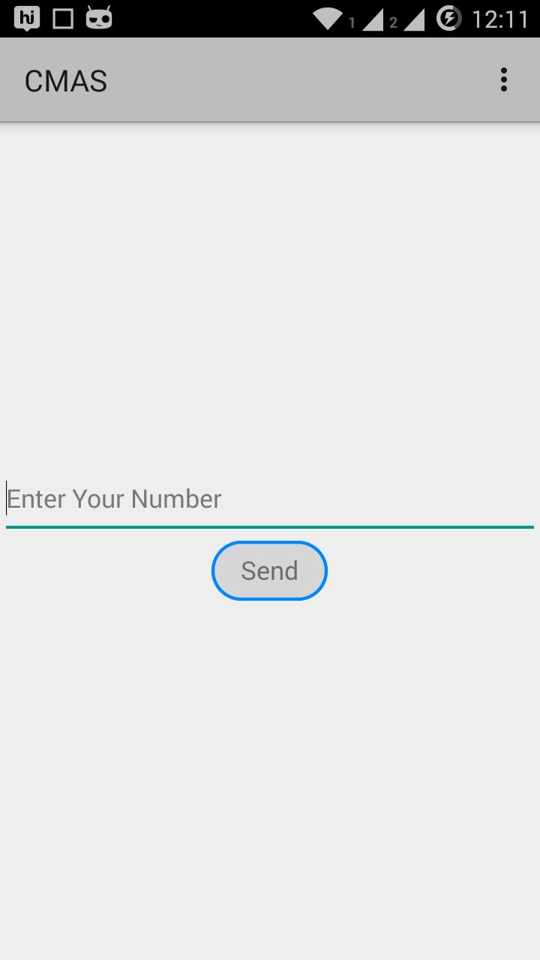

5.1.3.User DatabaseStructure:
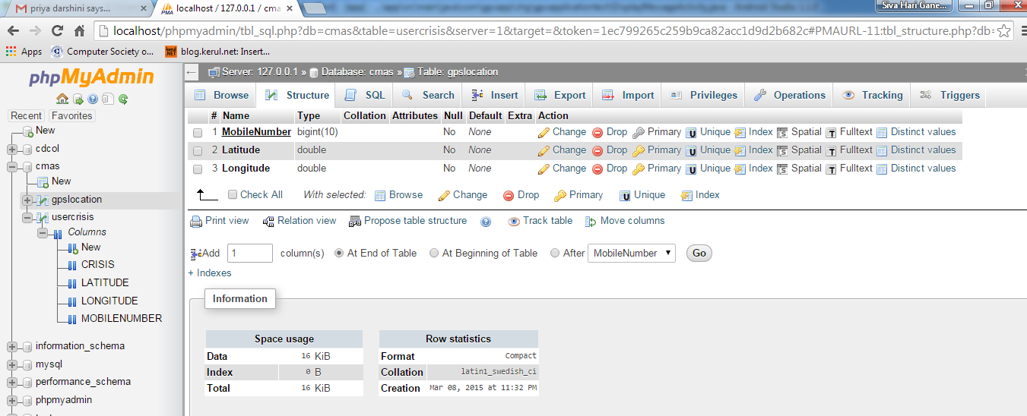
5.1.4. Registering into the Database:

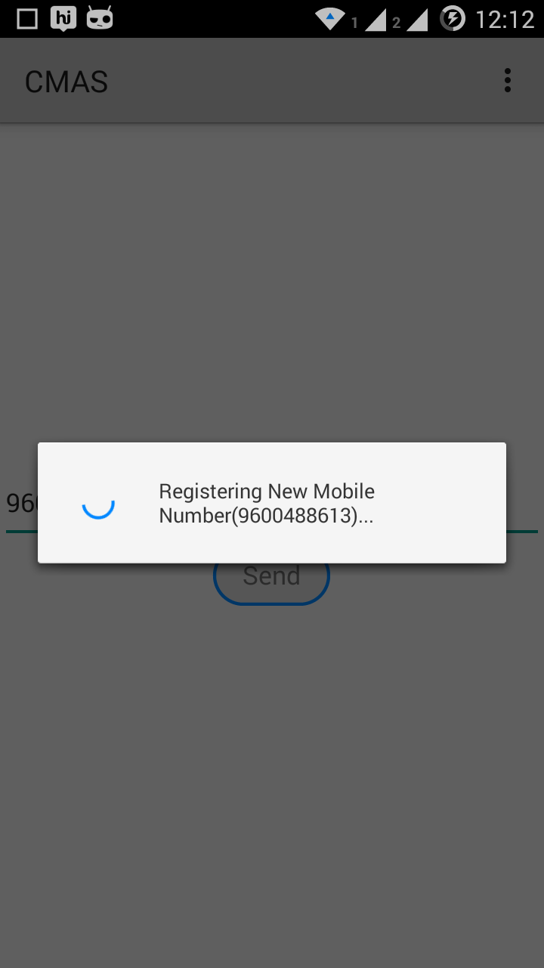

5.1.5. Registered Database Entry:
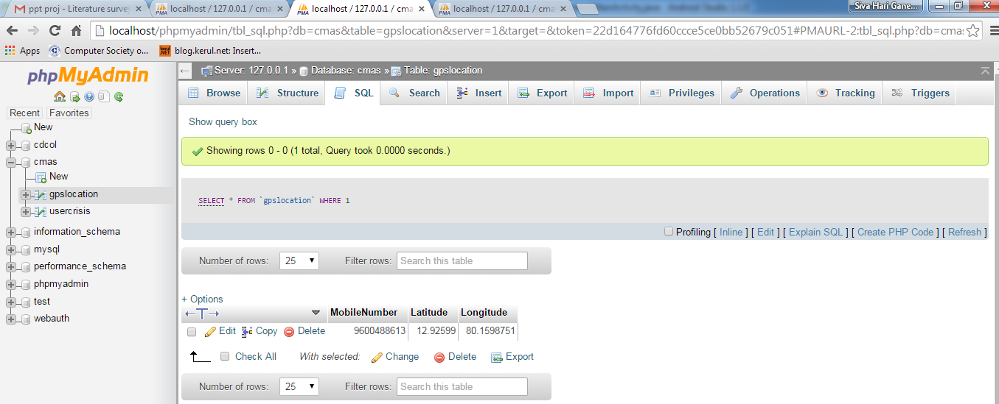
5.1.6. Xampp Control Panel: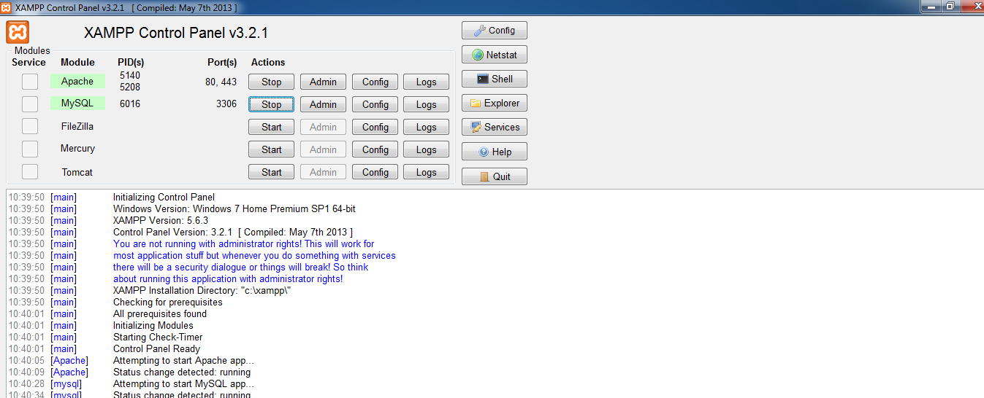

5.1.7.Crisis Database Structure:
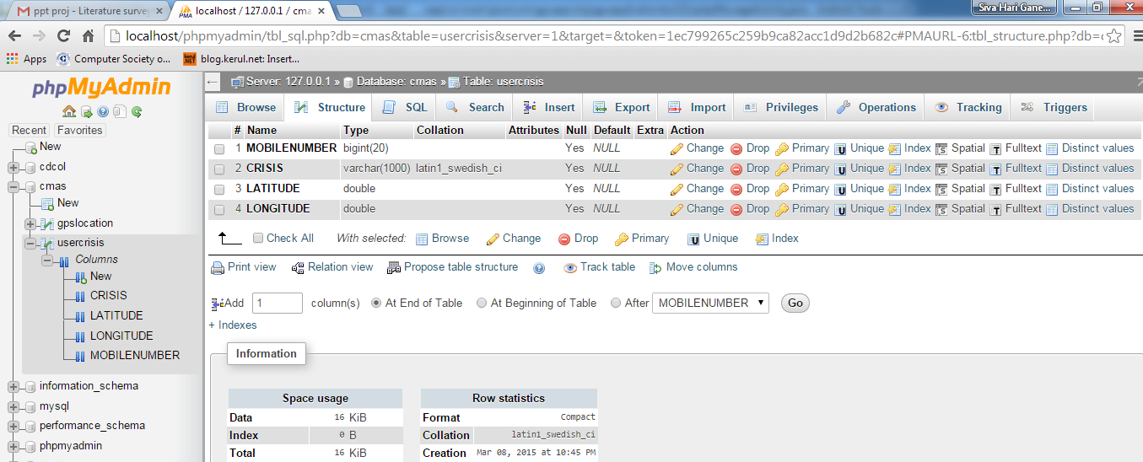

5.1.8.Crisis Report Page:
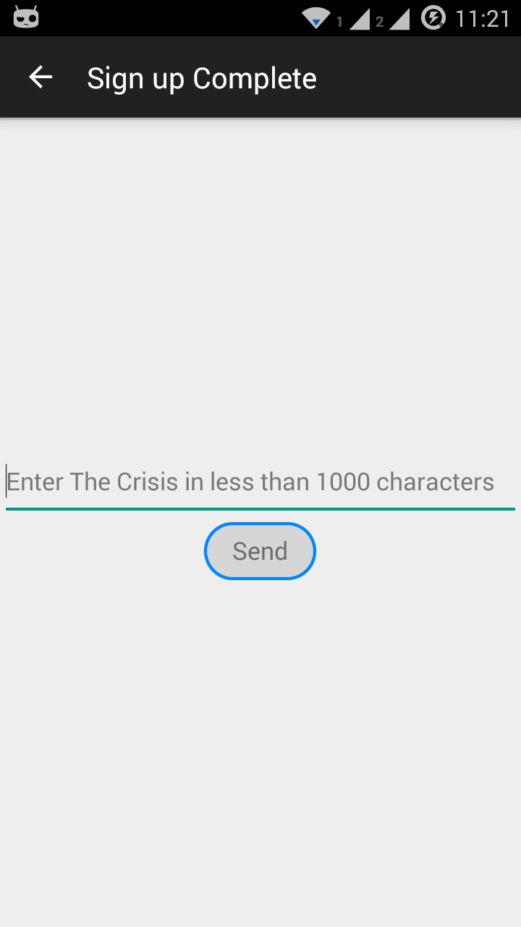

5.1.8.Crisis Database Entry:
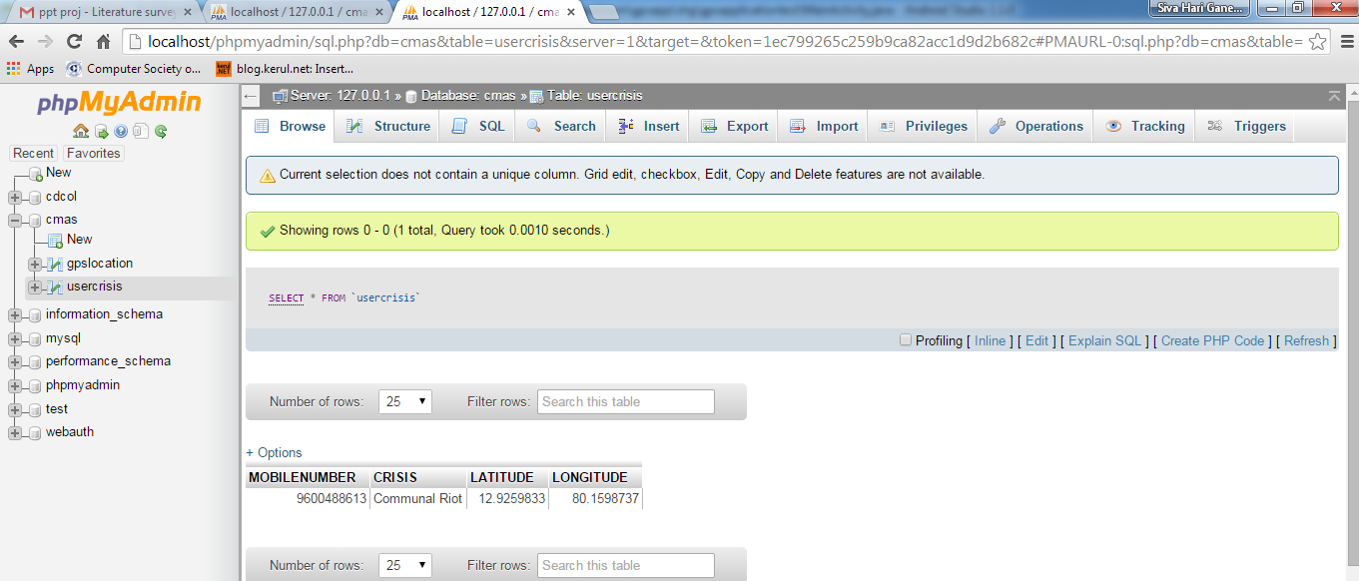

6. CONCLUSION

CHAPTER 6
CONCLUSION

The intrinsic purpose of any technology is to advance the quality of living. Technology is a light that cuts through darkness and touches lives. The development of an application that helps general public to be warned of an occurring crisis will go a long way in helping the public to act responsibly. This coupled along with the low cost technology available come together in building a system that greatly reduces the need for dependency on others social media. This application serves as an assisting aid for the general public as they are ignorant to their surrounding environment. Through this application, the government could establish a more personal reach to its civilians. It enhances the civilians access to any sort of instruction regarding the crisis. Since this works in a real time environment and also involves fairly simple logic, it has immense potential.

7. REFERENCES

CHAPTER 7
REFERENCES

- DWAS (Disaster Warning and Alert System) a Public Works Department project.
- Sms Gateway - http://en.wikipedia.org/wiki/SMS_gateway
- Network Sub switching - http://en.wikipedia.org/wiki/Network_switching_subsystem

